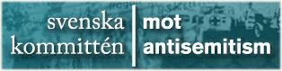
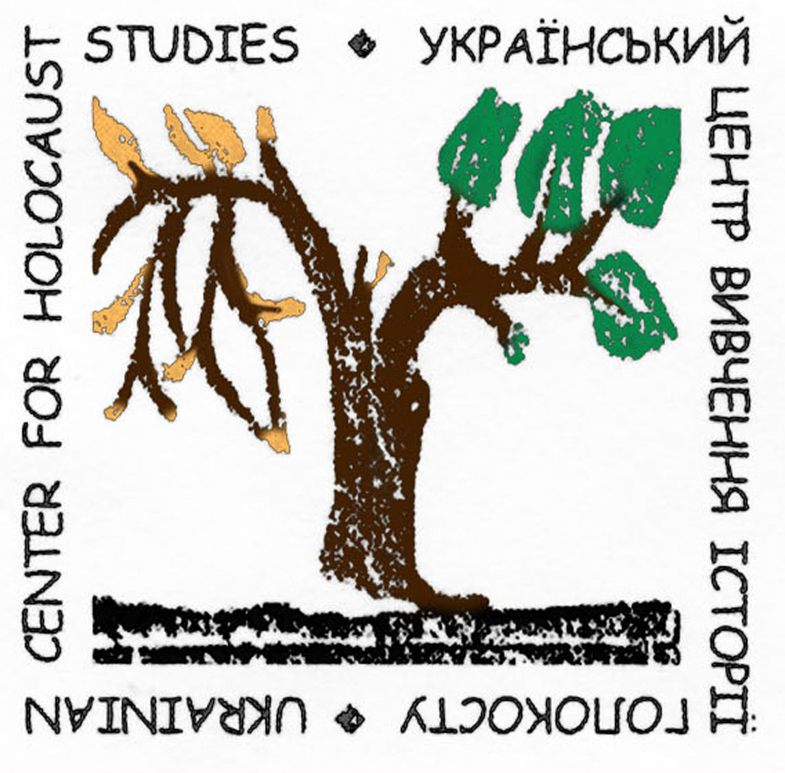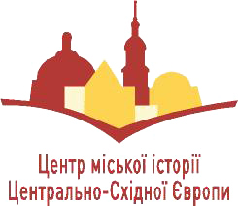

Program for Swedish Educators Visiting Ukraine
July 29 – August 2, 2012

(Timing is approximate and may change along the way)
29 July, Sunday
 | First tour of Lviv. General history. Accent on pre-war Jewish history.
 | Center for Urban History of East Central Europe. Short opening of the seminar and expectations of participants. Analysis of the program to come. Reflections of the day.
30 July, Monday
 | Second tour of Lviv. Jews of Lviv in inter-war period and up to 1941 and the Nazi occupation.
Center for Urban History. Presentations and discussions. With coffee-breaks:
1. Information pool for the Jewish history at the Center for Urban History.
2. Jews of Ukraine in the inter-war period. Peculiarities of different regions.
3. Lviv in the first week of Nazi occupation. Jewish pogrom.
Center for Urban History. Presentations and discussions.
4. The Holocaust in Ukraine.
31 July, Tuesday
8.30 | Meeting hall. Presentations and discussions:  1. The Holocaust and Jewish community in Western regions of Ukraine.
10.00 | Trip to Drohobych. Tour of Drohobych.
app. 13.30 | Tour of Sambir and Stary Sambir.
app. 17.00 | Return to Truskavets. Free time.
1 August, Wednesday
9.00 | Meeting hall. Presentations and discussions about history of the region.  1. Ukrainian-Jewish relations in retrospective.  2. Collaboration in the Holocaust.  3. Menten Case. (By Katty Hauptman)
12.30 | Tour of Truskavets
14.30 | Tour of the small villages and towns in the area.  Boryslav, Skhidnytsia, Urych, Pidhorodtsi etc.
2 August, Thursday
11.00 | Center for Urban History. Presentations and discussions. With coffee-breaks:  1. The Holocaust in Lviv.  2. Resistance and the Righteous in Ukraine and Lviv.  3. Holocaust commemoration in Ukraine.
15.00 | Tour of Lviv Holocaust sites.
18.00 | Center for Urban History.  Feedback session. Evaluation of Ukrainian part of the tour.
3 August, Friday
Departure to Poland.

